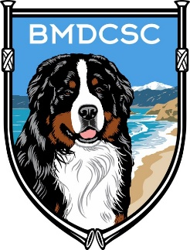BERNESE MOUNTAIN DOG CLUB OF SOUTHERN CALIFORNIA
ADOPTION APPLICATION

Name: |  | Date:

Address:

Phone (Home): |  | Cell:

E-Mail:

Referred to BMDCSC by:

Veterinarian:

Type of Home Dwelling:

Own: |  | Rent: |  | House: |  | Condo: |  | Apt:

Do you have a yard? | Yes |  | No

Do you have an enclosed fence? | Yes |  | No

If Yes, what type and how high?

Please describe why you want a Bernese Mountain Dog; what are you interested in doing
with your dog?

Have you ever owned a dog before? |  | Yes |  | No
If so, which breeds?

Do you currently have other animals? | Yes |  | No

Please list type and number:
Do you have children in the home? | Yes
 | No
If Yes, Please list with ages

Is someone home during the day? | Yes |  | No

Where will the dog be during the day?
Where will the dog be at night?

Do you have a gender preference? | Male |  | Female
 | No Preference

It is our practice to conduct home visits prior to approving adoption applications:

Are you willing to have a member of the BMDCSC Rescue Committee visit your home prior to adoption? | Yes |  | No

Are you willing to accept follow-up phone calls and/or home visits after adoption? | Yes |  | No

Do all family members want a dog? | Yes |  | No

Who will be responsible for the dog’s care?

What are the occupations of the adults in the home?

How many hours per day will the dog be left alone?

When alone, where will the dog be kept?

What will you do with the dog if you are called out of town or go on vacation?

Will you agree and commit to return the dog to the BMDCSC Rescue Program should anything prevent you from keeping the dog? | Yes |  | No

Do you have any additional comments or information you want to share?

Signature:
Please return completed form to:
Rachel Finlay
2 Roundtree Court
Aliso Viejo, CA 92656
949-246-1657
rachel_finlay@yahoo.com

